GRM Team for OBGYN Conference:


Jessica Patterson, MD FAAEM
American Emergency Medicine Physician
Medical Degree from Columbia University College of Physicians & Surgeons
Completed Emergency Medicine Residency and Emergency Medicine Ultrasound Fellowship at Temple University
Assistant Professor of Emergency Medicine at Temple University
Fellowship Director of AROW (Austere-Remote-Operational-Wilderness) Fellowship at Temple
Global Ultrasound Director at Temple
Ultrasound Director at Global Response Management


Dr. Alyssa Green, MD, MPH
American Emergency Medicine Physician
Medical Degree from Temple University School of Medicine, Philadelphia, PA
Completed Emergency Medicine Residency at Temple University Hospital, Philadelphia, PA
Completed Global Health Fellowship at Columbia University Medical Center, New York City, NY
Completed Masters of Public Health—Public Health and Humanitarian Action, Mailman School of Public Health, New York City, NY
Attending physician at Presbyterian Hospital System, Albuquerque, NM

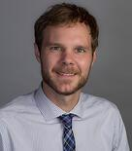
Brian Berg, DO
American Emergency Medicine Physician
Austere, Remote, Operational, Wilderness Medicine Fellow, Temple University
Adjunct Clinical Instructor - Department of Emergency Medicine, Lewis Katz School of Medicine at Temple University
Candidate for Fellowship in the Academy of Wilderness Medicine, Wilderness Medical Society

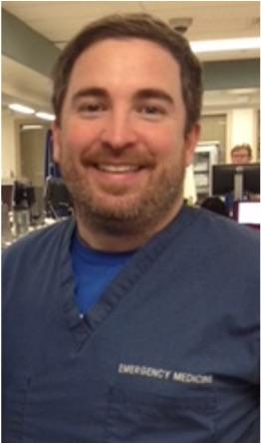
Ryan C. Gibbons, MD, Associate Professor of Emergency Medicine, Lewis Katz School of Medicine at Temple University

