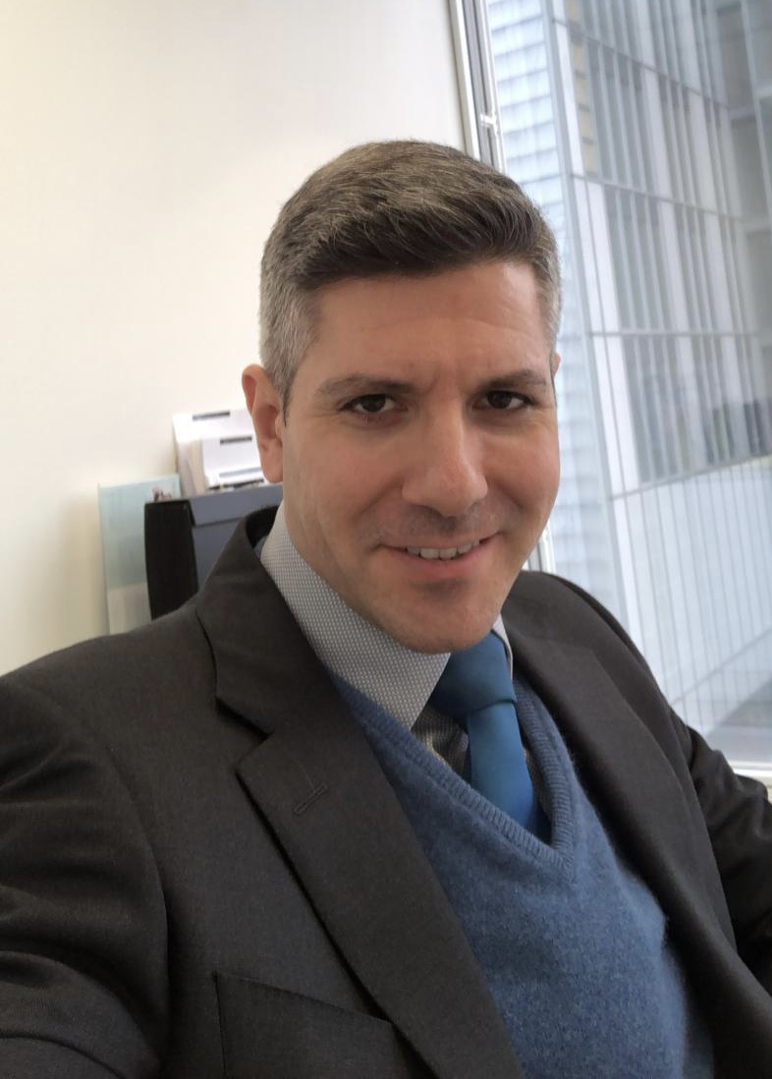

Mr Fevzi Shakir BSc(Hons) MBBS MRCOG MSc
Consultant Gynaecologist

NHS Base: Royal Free Hospital, Hampstead, London
Private Practice: Cleveland Clinic London

British Society for Gynaecological Endoscopy (BSGE) Officer
Honorary Treasurer

Medical Advisor to Endometriosis UK Charity

Mr Fevzi Shakir is a Consultant Gynaecologist specialising in Advanced Minimally Invasive Gynaecological Endoscopic Surgery. He works at the Royal Free Hospital, London. He completed a 2 year Senior Clinical Research Fellowship in Advanced Gynaecological Endoscopic Surgery, based at the Minimal Access Therapy Training Unit (MATTU) in Guildford.

In 2014 he was elected as a council member in charge of the trainee portfolio for the British Society for Gynaecological Endoscopy (BSGE) and re elected in 2016. He founded a trainee group as part of the BSGE called RIGS (Registrars in Gynaecological Surgery) aiming to improve training and resources. In 2017 he was elected as a senior member of council on the BSGE and appointed as chair of the guidelines and patient information committee and later Chair of Website and Digital Governance Subcommittee for which he was re-elected in 2020. In 2021 he was elected as Honorary Treasurer for the Society.

He has presented both Nationally and Internationally on over 80 occasions, has over 20 peer reviewed publications in scientific journals, including randomised controlled trials. He has received both National and International prizes (including the prestigious Golden telescope award in 2016) & bursaries at scientific meetings on over 10 occasions, for his contribution and work in minimally invasive gynaecological surgery.

He has completed an MSc in Advanced Gynaecological Endoscopy, with Merit, based at the University of Surrey. He is involved with producing national guidelines and service specifications for the RCOG/BSGE and NHS England. He is a key opinion leader for medical devices used for laparoscopic surgery and one of the medical advisors to Endometriosis UK.

He is part of over 20 National and International teaching faculty for endoscopic surgery, is a key opinion leader for several surgical device manufacturers and is a medical advisor to Endometriosis UK.

In 2014, he ran the London Marathon in 3 hours, 49 minutes and 21 seconds for the Endometriosis UK charity, raising £2,333.75. In 2016, 2017, 2018, 2019 and 2022 he ran the British Vitality London 10Km run again for Endometriosis UK, raising over £5,000 in total.

